How to test on production stage of MerchantWARE 123

- Completed Installation of MS POS for .NET 1.12 at local computer
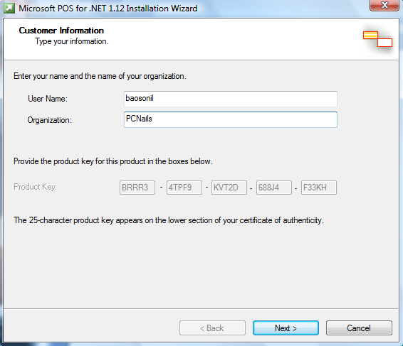
Microsoft C++ 2005

After completed installation then how to config & setup (Based on “Transport User Guide”) We don’t have user and password)
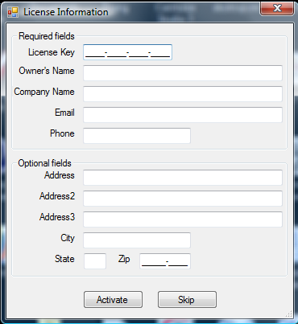
Click SKIP

